
Company
Logotype

Cone Beam Computed Tomography- Report



Porur Dental X-rays & CBCT

Patient Name : Mrs. Anukanthi | Date of Report : 24.05.2024
Age/ Gender : 72 years/ Female | Region of Interest : CBCT Sectional Mandible
Referring doctor: Dr. V. Sasikumar | Indication : Pain in relation to 4th quadrant
Clinical Notes: Nil
PATIENT INFORMATION

CBCT- Sectional Mandible provided
CBCT – IMAGE DETAILS

RADIOGRAPHIC INTERPRETATION

- In relation to 46, the distal aspect of crown is present with loss of enamel and dentin.
- Complete loss of crown and root structure in relation to 48 region.
- In relation to 47, presence of a small hyperdense structure within the alveolar bone at a distance of 14.15 mm from the alveolar ridge and at close proximity to the inferior alveolar nerve canal. The hyperdense structure is diffuse in nature with a surrounding hypodensity.

RADIOGRAPHIC IMPRESSION

- Partially edentulous mandibular ridge.
- Root stumps: 47

Kindly correlate with clinical findings


IMAGES FOR REFERENCE

RECONSTRUCTED PANORAMIC VIEW

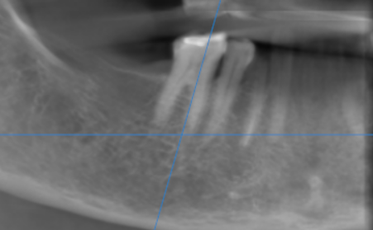

3-DIMENSIONAL VIEW

MULTIPLANAR VIEW

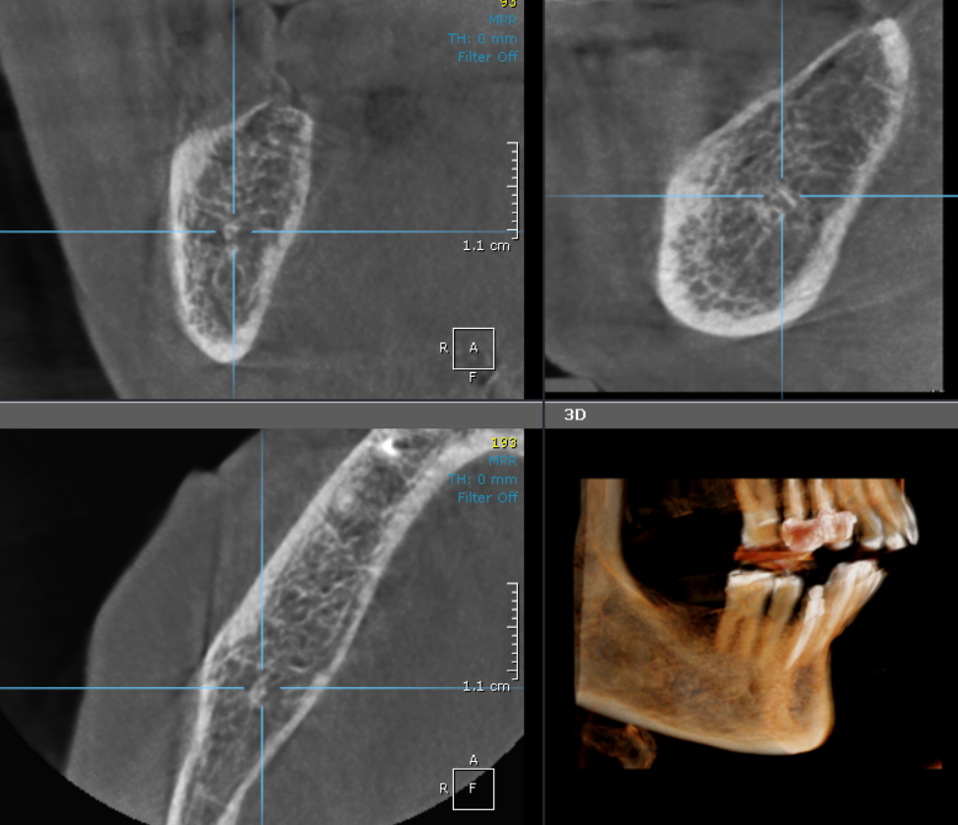

SAGITTAL VIEW
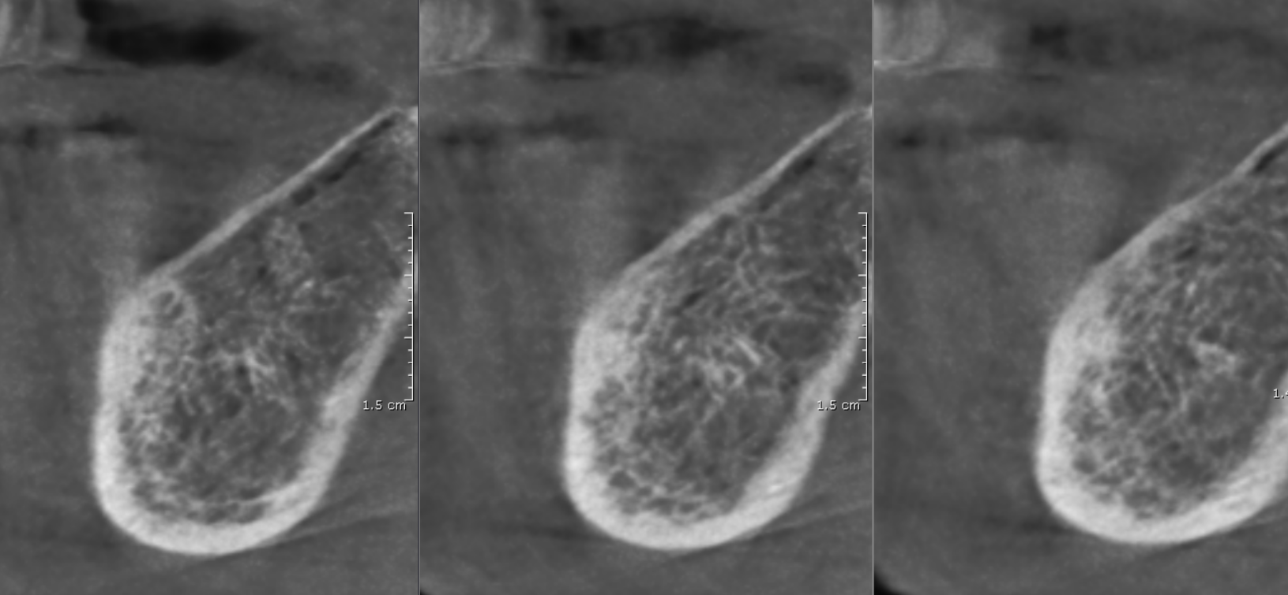

**** End of report ****

